# Passion Spa FAQ (All prices are in Dollars and net to us)

## General

### Steps

3 tier steps are available for the Aquatic 1, 2 and 3 in grey to match surround

Plain $275

With stainless steel bar $399

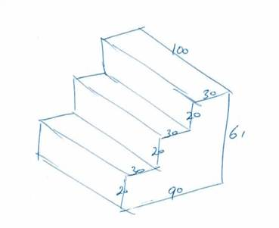

### Warranty

Parts – (Pumps, electronics, blower etc) 2 years comprehensive warranty. ( Other manufacturers offer 5 years, but if looked at closely they break down and not as good as they first appear).

Shell – 10 years

Only available in standard colours, white with grey surround.

Stereo fitted $1075

In-ground installation requires 1 meter access all the way around recommended. Minimum 60cm.

### Lead time

14 to 21 days from placing order and payment received. Usually within 14 days.

## Aquatic 1

Cover lifters are available (Cabinet mount assist lift). 2 required $225 each

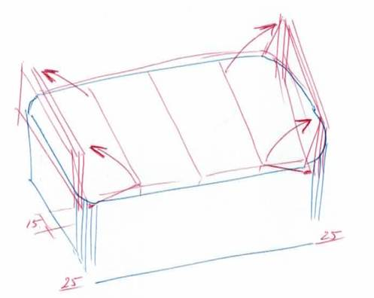

# Aquatic 3

Has 2 heaters so both sides can be heated independently at different temperatures at the same time

The pool area and spa area can go up to 40 degrees, but not recommended for swimming in.

A hard cover that you can walk on is available for $450

Stereo available for $1075

An average daily running cost can be quoted at around £6.00. This is based on using both sides twice a day, the spa at 40 degrees and the swim side at 29, at this time of year (Feb). Naturally that should decrease as it warms up through the summer