SAFETY DATA SHEET – Sodium Hypochlorite 10/11%

SECTION 1 | IDENTIFICATION OF THE SUBSTANCE/MIXTURE AND OF THE COMPANY/UNDERTAKING
1.1 Product identifier |  | Sodium Hypochlorite 10/11%  Substance name: sodium hypochlorite, solution 10-11 % Cl active  EC No. 231-668-3 CAS No. 7681-52-9  REACH Reg. No. 01-2119488154-34-xxxx
1.2 Relevant identified uses of the substance or mixture and uses advised against |  | Intended use: chlorination of swimming pools
1.3 Details of the supplier of the SDS |  | A & R Products (South East) Ltd  Europa House  Pivington Mill  Pluckley Kent TN27 0PG
 |  | SDS compiler: mail@arproducts.co.uk
1.4 Emergency telephone number: |  | 01233 841855 (Monday – Friday 9.00 – 17.00 hrs GMT)
SDS Issue 2: 13/04/2018

SECTION 2 | HAZARDS IDENTIFICATION
2.1 Classification of the substance or mixture  see section 16 for full text of H statements |  | Classification to CLP ((EC) No 1272/2008):  Skin Corrosion, Category 1B; H314  Acute aquatic toxicity, Category 1; H400
2.2 Label elements  Note: italicized items (H and P Statements codes) are not included on label |  | Labelling in accordance with CLP ((EC) No 1272/2008) (as amended)  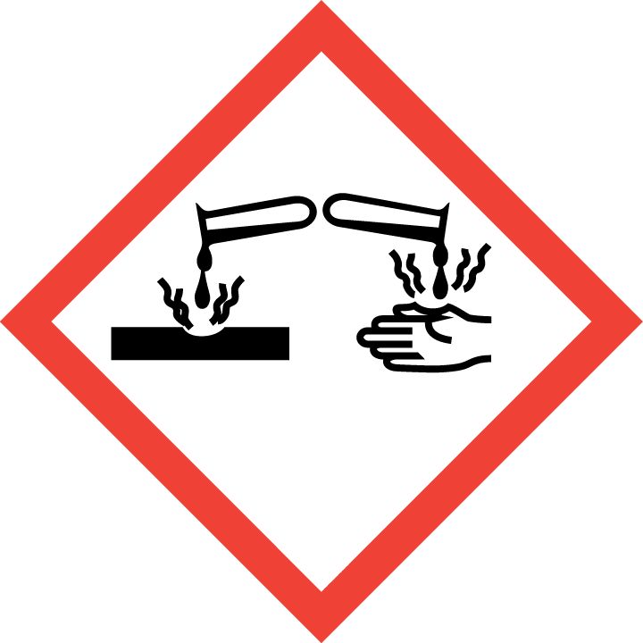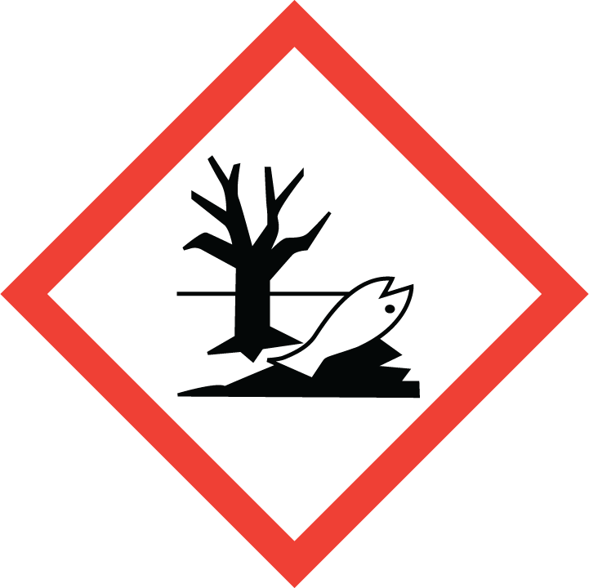  DANGER  H314 Causes severe skin burns and eye damage.  H400 Very toxic to aquatic life.  P260 Do not breathe vapours.  P273 Avoid release to the environment.  P280 Wear protective gloves/ protective clothing/eye protection/ face protection.  P301 + P330 + P331 IF SWALLOWED: rinse mouth. Do NOT induce vomiting.  P303 + P361 + P353 IF ON SKIN (or hair): Remove/ Take off immediately all contaminated clothing. Rinse skin with water/ shower.  P305 + P351 + P338 IF IN EYES: Rinse cautiously with water for several minutes. Remove contact lenses, if present and easy to do so. Continue rinsing.  EUH206 Warning! Do not use together with other products. May release dangerous gases (chlorine).  EUH031 Contact with acids liberates toxic gas.  P102 Keep out of reach of children.  P101 If medical advice is needed, have product container or label at hand.  Hazardous components listed on the label: Sodium hypochlorite, solution
2.3 Other hazards |  | No other information is available.

SECTION 3 | COMPOSITION / INFORMATION ON INGREDIENTS
3.1 Substances
Hazardous Ingredients:  see section 16 for full text of classification phrases  Exposure limit values exist for the following: |  | Sodium hydroxide
  Chemical Name | EC No. | CAS No. | CLP Classification | Concn. %
  Sodium hypochlorite  REACH Reg. No.  01-2119488154-34-xxxx | 231-668-3 | 7681-52-9 | Skin Corr. 1B; H314  Aquatic Acute 1; H400 | 10-11
  Sodium hydroxide  REACH Reg. No.  01-2119457892-27-xxxx | 215-185-5 | 1310-73-2 | Skin Corr. 1A; H314 | 0-5

SECTION 4 | FIRST AID MEASURES
4.1 Description of first aid measures |  | General advice : Take off all contaminated clothing immediately.  If inhaled : In case of accident by inhalation: remove casualty to fresh air and keep at rest. If breathing is irregular or stopped, administer artificial respiration. Call a physician immediately.  In case of skin contact : Wash off immediately with soap and plenty of water. If irritation  appears or if the contamination is important, seek medical advice.  In case of eye contact : Rinse immediately with plenty of water, also under the eyelids,  for at least 15 minutes. Consult an eye specialist or an ophthalmic hospital if possible.  If swallowed : Clean mouth with water and drink afterwards plenty of water. Never give anything by mouth to an unconscious person. If swallowed, do not induce vomiting - seek medical advice. If a person vomits when lying on his back, place him in the recovery position.
4.2 Most important symptoms and effects, both acute and delayed |  | Inhalation may provoke the following symptoms:  Cough, Headache, Lung oedema  Risk of serious damage to the lungs (by aspiration).
4.3 Indication of immediate medical attention and special treatment needed, if necessary |  | In case of eye contact : Rinse immediately with plenty of water, also under the eyelids,  for at least 15 minutes  Treat symptomatically.  Later control for pneumonia and lung oedema.

SECTION 5 | FIREFIGHTING MEASURES
5.1 Extinguishing media |  | Use extinguishing measures that are appropriate to local  circumstances and the surrounding environment.  The product itself does not burn.
5.2 Specific hazards arising from the substance or mixture |  | Fire may cause evolution of: Chlorine, Hydrogen chloride gas,  Chlorine oxides
5.3 Advice for fire-fighters |  | In the event of fire, wear self-contained breathing apparatus.  Wear appropriate body protection (full protective suit)  Further information : Cool closed containers exposed to fire with water spray.  Heating will cause a pressure rise - with risk of bursting.  Collect contaminated fire extinguishing water separately. This must not be discharged into drains.

SECTION 6 | ACCIDENTAL RELEASE MEASURES
6.1 Personal precautions, protective equipment and emergency procedures |  | Use personal protective equipment. Wear respiratory protection. Keep people away from and upwind of spill/leak.  Provide adequate ventilation. Danger of slipping if spilled  Avoid contact with skin and eyes. Do not breathe vapour.
6.2 Environmental precautions |  | Do not flush into surface water or sanitary sewer system.  Avoid subsoil penetration.  If the product contaminates rivers and lakes or drains, inform respective authorities.  If material reaches soil inform authorities responsible for such cases.
6.3 Methods and material for containment and cleaning up |  | Absorb with liquid-binding material (sand, diatomite, acid binders, universal binders). Keep in suitable, closed containers for disposal.  Further information : Treat recovered material as described in the section "Disposal considerations".
6.4 Reference to other sections |  | Personal protective equipment: See section 8

SECTION 7 | HANDLING AND STORAGE
7.1 Precautions for safe handling |  | Do not keep the container sealed. Handle and open container with care. Ensure adequate ventilation. Use personal protective equipment. Avoid contact with the skin and the eyes. Do not breathe vapours or spray mist. Use respirator with appropriate filter if vapours or aerosol are released. Emergency eye wash fountains and emergency showers should be available in the immediate vicinity.  Hygiene measures : Keep away from food, drink and animal feedingstuffs. Smoking, eating and drinking should be prohibited in the application area.  Wash hands before breaks and at the end of workday. Take off all contaminated clothing immediately. Avoid contact with the skin and the eyes. Do not breathe vapours or spray mist.
7.2 Conditions for safe storage, including any incompatibilities |  | Keep in an area equipped with alkali resistant flooring. Keep only in the original container. Store in a receptacle equipped with a vent.  The product is not flammable. Normal measures for preventive fire protection.  Keep in a well-ventilated place. Protect against light. Store in cool place. Do not keep the container sealed.  Keep away from food, drink and animal feedingstuffs. Do not store together with acids and ammonium salts.
7.3 Specific end use(s) |  | For chlorination of swimming pools
SECTION 8 | EXPOSURE CONTROLS / PERSONAL PROTECTION
8.1 Control parameters |  |  | Workplace Exposure Limits (WEL):  Sodium hydroxide: STEL (15 min. exposure) 0.5 ppm 1.5 mg/m3
8.2 Exposure controls |  |  | Refer to protective measures listed in sections 7 and 8.  Use respirator with appropriate filter if vapours or aerosol are  released. Recommended Filter type:  Combination filter: B-P2 or Combination filter: B-P3.  Wear protective gloves and replace at first signs of wear.  Material: butyl-rubber Gloves: 8 h. Glove thickness: 0.5 mm  Material: PVC: Gloves: 8 h.: Glove thickness: 0.5 mm  Material: polychloroprene: Gloves: 8 h: Glove thickness: 0.5 mm  Eye protection: Tightly fitting safety goggles  Skin and body protection: alkali resistant protective clothing  Environmental exposure controls: Do not flush into surface water or sanitary sewer system. Avoid subsoil penetration.  If the product contaminates rivers and lakes or drains, inform  respective authorities. If material reaches soil inform authorities responsible for such cases.

SECTION 9 | PHYSICAL AND CHEMICAL PROPERTIES
9.1 Information on basic physical and chemical properties – does not constitute a specification
 | Appearance | yellowish green liquid
 | Odour | slight chlorine
 | Odour threshold | no data available
 | pH | >11
 | Melting Point/Freezing point (°C) | -17
 | Initial boiling point/boiling range (°C) | 110
 | Flash Point (°C)(closed cup) | not applicable (non-flammable)
 | Evaporation rate | no data available
 | Flammability | not applicable (non-flammable)
 | Upper/lower flammability limits | not applicable (non-flammable)
 | Vapour pressure (mbar @ 20°C) | no data available
 | Vapour density | >1.0 (air=1.0)
 | Relative Density (@15.5°C) | 1.2 – 1.3
 | Solubility in water | fully soluble
 | Solubility in fat / solvent | not miscible
 | Partition coefficient (log Pow) | no data available
 | Autoignition temperature (°C) | not applicable (non-flammable)
 | Decomposition temperature | no data available
 | Viscosity (mPa.s @ 20°C) | 3.45 (Aqueous, solution, 15 %)
 | Explosive properties | not explosive
 | Oxidising properties | none
9.2 Other information |  | None

SECTION 10 | STABILITY AND REACTIVITY
10.1 Reactivity |  | This product is a very reactive substance that can react with  many inorganic and organic compounds.
10.2 Chemical stability |  | Decomposes on heating.  Decomposes on exposure to light
10.3 Possibility of hazardous reactions |  | May develop chlorine if mixed with acidic solutions
10.4 Conditions to avoid |  | Avoid high temperatures and exposure to sunlight
10.5 Incompatible materials |  | Acids, ammonium compounds, Acetic anhydride, Organic materials, Hydrogen peroxide, metal salts, Copper, Nickel, Iron
10.6 Hazardous decomposition products |  | Chlorine (Hydrogen chloride gas, chlorine oxides)

SECTION 11 |  | TOXICOLOGICAL INFORMATION
11.1 Information on toxicological effects
 | Acute Toxicity  -oral  -inhalation  -dermal |  | LD50: 2,900 - 3,400 mg/kg (species: mouse)  LC50: > 10.5 mg/l (species: rat)  LD50: > 2,000 mg/kg (species: rabbit)
 | Corrosivity/Irritation  -eye  -skin  -respiratory system |  | Corrosive effects (rabbit) Risk of serious damage to eyes.  Severe skin irritation (OECD Test Guideline 404: rabbit)  Corrosive effects (human experience)
 | Sensitisation -skin  -respiratory |  | Not sensitizing (guinea pig)  No data available
 | germ-cell mutagenicity  carcinogenicity  reproductive toxicity |  | No data available  No data available  No data available
 | STOT single exposure  STOT repeated exposure |  | No data available  No data available
 | aspiration hazard |  | No data available

SECTION 12 | ECOLOGICAL INFORMATION
12.1 Toxicity |  | Fish: LC50 (96 hr.): 0.22 – 0.62 (species: Pimephales promelas)  Daphnia magna: EC50 (96 hr.): 2.1 mg/l  Algae: EC50 (24hr.) 28 mg/l (species: Desmodesmus subspicatus)
12.2 Persistence and degradability |  | The methods for determining the biological degradability are not  applicable to inorganic substances
12.3 Bioaccumulative potential |  | Bioaccumulation is not expected
12.4 Mobility in soil |  | The product is mobile in water environment.
12.5 Results of PBT and vPvB assessment |  | No known PBT or vPvB chemicals present
12.6 Other adverse effects |  | All numerical values for ecotoxicity effects are calculated on the  pure substances.  Do not flush into surface water or sanitary sewer system.

SECTION 13 | DISPOSAL CONSIDERATIONS
13.1 Waste treatment methods
 | Waste Residue: | Disposal together with normal waste is not allowed. Special disposal required according to local regulations. Do not let product enter drains. Contact waste disposal services.  European Waste Code: No waste code according to the European Waste Catalogue assigned for this product. The waste code is established in consultation with the regional waste disposer.
 | Packaging: | Contaminated packaging: Empty contaminated packagings thoroughly. They can be recycled after thorough and proper cleaning. Packagings that cannot be cleaned are to be disposed of in the same manner as the product

SECTION 14 | TRANSPORT INFORMATION
Classified as dangerous goods for carriage under ADR/RID/ADN/IMDG/ICAO/IATA regulations
14.1 UN Number |  | UN 1791
14.2 UN Proper shipping name |  | HYPOCHLORITE SOLUTION
14.3 Transport hazard class(es) |  | 8
14.4 Packing group |  | III
14.5 Environmental hazards |  | Classified as Environmentally Hazardous Substance / Marine Pollutant
14.6 Special precautions for user |  | See section 8 for safe handling
14.7 Transport in bulk according to Annex II of MARPOL 73/78 and the IBC Code |  | Not applicable to packaged goods

SECTION 15 | REGULATORY INFORMATION
15.1 Safety, health and environmental regulations/legislation specific for the substance or mixture |  | Supply regulations: Classified as hazardous under DSD/GHS/CLP criteria (DSD: Dangerous Substances Directive; GHS: Globally Harmonised system of classification and labelling of chemicals;  CLP: Classification, Labelling and Packaging regulations)  Transport regulations: Classified as Dangerous Goods for Carriage under ADR/RID/IMDG/ICAO/IATA regulations
15.2 Chemical Safety Assessment |  | No formal chemical safety assessment has been carried out

SECTION 16 | OTHER INFORMATION
Full text of classification data in sections 2 and 3

Skin Corr. 1B; H314 | Skin corrosion category 1B; Causes severe skin burns and eye damage
Skin Corr. 1A; H314 | Skin Corrosion category 1A: Causes severe skin burns and eye damage
Aquatic Acute 1; H400 | Acute aquatic toxicity category 1; Very toxic to aquatic life.

Further references: Occupational exposure limits (EH 40)
COSHH essentials (HSG 193)

All sections have been amended in this revision to comply with the requirements of
REACH Annex II as amended by (EU) 2015/830

The information provided in this Safety Data Sheet is correct to our knowledge at the date of its revision. The information given only describes the products with regard to safety arrangements
and is not to be considered as a warranty or quality specification and does not constitute a legal relationship. The information contained in this Safety Data Sheet relates only to the specific material designated and may not be valid for such material used in combination with any other material or in any process, unless specified in the text

